 **Appendix 1**

**17/02832/FUL 276-280 Banbury Road, Summertown**

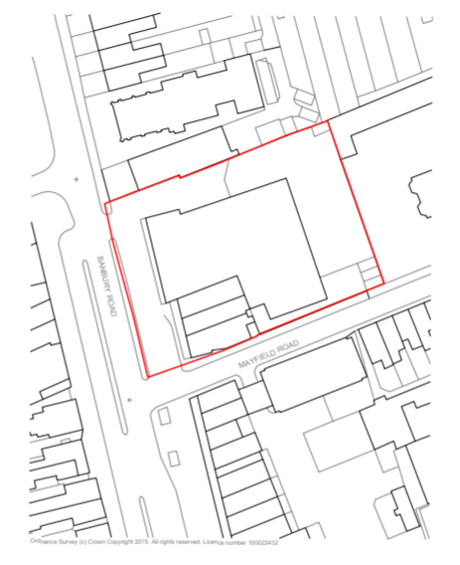

N